



# Welcome!

Hello Whip-Ma-Whop-Ma-Hoppers! It’s almost the weekend of our fantastic event, so here’s all the information you need to get you excited and raring to hop!

Meet the team

Here are the three key faces you need to know this weekend. Please give them a ring, or stop them as they pass by, if you have any questions, problems, or just want a dance!



Serious stuff

Here’s the serious but important bit about keeping safe during the weekend. It is expected that you behave in a safe and considerate manner which includes careful floorcraft but we understand that accidents can happen. Laura Cook and Sarah Weinberg are first aid trained so can deal with minor injuries. In case of an emergency, please call Campus Security on 01904 323333 as they will be the quickest to the scene and will contact emergency services if required.

We want to make sure everybody has the best weekend possible so if you are having any problems with another individual or feel that somebody is in any way violating the terms of the code of conduct then please speak to one of the above contacts and they will deal with the situation as necessary. Please do not give any unsolicited feedback in the workshops or on the social dancefloor. To see our full code of conduct, please see the event website.

Now that’s out of the way, here’s the fun bit...

# Timetable

|  |  |
| --- | --- |
| **FRIDAY 10TH FEBRUARY** | |
| 19:00-23:30 | Welcome Dance & Registration |
| **SATURDAY 11TH FEBRUARY** | |
| 10:00-12:30 | Workshop 1 |
| 12:30-14:00 | Break |
| 14:00-16:30 | Workshop 2 |
| 16:30-17:00 | Break |
| 17:00-18:00 | Taster 1: Scott and Jenny – Jam Circles |
| 18:00-20:00 | Break |
| 20:00-00:00 | Social Dance – ‘Behind the Silver Screen’ |
| 00:00-03:00 | After Party @ Macumba Cocktail Bar |
| **SUNDAY 12TH FEBRUARY** | |
| 10:30-13:00 | Workshop 3 |
| 13:00-14:30 | Break |
| 14:30-15:30 | Taster 2: Bic and Simone – Solo Charleston Routine |
| 15:30-15:45 | Break |
| 15:45-16:45 | Taster 3: Hector and Sonia – Rhythms in Lindy |
| 16:45-18:30 | Break |
| 18:30-22:30 | Social Dance – ‘Pyjama Party’ |

Rooms for each stream of workshops will be on your individual timetable included in your welcome pack.

# General information

Registration

You can register at Friday night’s social at the De Grey Rooms from 7pm. This is when you’ll get your welcome pack, which will include your timetable and wristband. You’ll be able to pick up your t-shirt if you ordered one too.

If you can’t make it on Friday evening, you will also be able to register on Saturday morning in Vanbrugh Dining Hall between 9.30 and 10am. Please make sure you leave enough time to get to your workshops, particularly if you’re in the Hoppers stream, as you’re on Heslington East, which is on the other campus – see below for details.

Workshops

Our three workshop locations are the Ron Cooke Hub (Hoppers), Vanbrugh Dining Hall (Boppers) and James Hall/Hendrix Hall (Toppers). All three locations are on the University Campus.

There will also be three taster classes for everyone during the weekend, which will all take place in Vanbrugh Dining Hall.

Our campus is split into two parts – Vanbrugh Dining Hall, James Hall and Hendrix Hall are all based on Heslington West Campus, however the Ron Cooke Hub is on the Heslington East campus. You can travel between campuses on a free bus (66 FirstYork), which takes about 5 minutes – please make sure you take this into account when estimating travel times.

Getting to campus by bus

The 66 FirstYork Bus runs from the train station to the campus approximately every 8 minutes. It takes roughly 20 minutes to reach the university, and the buses also stop in the city centre.

Taxis

A taxi from the train station to the University costs approximately £7 to £8.   
Below are some taxi numbers which may be of use this weekend:

* Getaway Cars – 01904 707070
* Streamline – 01904656565
* Fleetways – 01904 365365
* York Car Taxis – 01904 765765

# Campus Map (Heslington West):

Follow this link to find an interactive google map that shows you workshop locations, event locations, and where to get food:

<https://www.google.com/maps/d/edit?mid=zUR65rJ3bw3E.kcG4OrKVH0dw&usp=sharing> 

Workshop Locations Key:

Vanbrugh Dining Hall

Hendrix Hall

James Hall

# Workshop directions:

## Vanbrugh Dining Hall (Heslington West)

Arriving by bus

To get to Vanbrugh Dining Hall, catch the 66 FirstYork and get off at the Library bus stop.

From the library bus stop, you must cross the road and continue in that direction. There is a sheltered walkway that will take you to the entrance of Vanbrugh (on your right). Entering Vanbrugh, follow the corridor until you see Vanbrugh Reception on your right. The Vanbrugh Dining Hall is on your left, through the double doors and straight ahead.

Arriving by car

The University of York website recommends you ‘approach the University from the junction of the A64 and A1079 on the east of the city, from where the University is signposted’.

The University postcode is YO10 5DD.

Parking

Parking is limited, but free at weekends. There are various car parks located near Vanbrugh Dining Hall:

## Workshop directions: James Hall (Heslington West)

Arriving by bus

To get to James Hall, catch the 66 FirstYork and get off at the Library bus stop.

From the library bus stop, you must cross the road and continue in that direction. There is a sheltered walkway that will take you to the entrance of Vanbrugh (on your right). Entering Vanbrugh, follow the corridor until you see Vanbrugh Reception on your right. Walk past Vanbrugh Reception and out of the automatic doors, through a small parking/delivery area. On your left is a bridge across the lovely lake. Intrepidly, cross the dangerous waters (beware piranhas and geese). Once safely across, follow the covered walkway until you are inside a building. You have successfully reached James Hall.

Arriving by car

The University of York website recommends you ‘approach the University from the junction of the A64 and A1079 on the east of the city, from where the University is signposted’.

The University postcode is YO10 5DD.

Parking is limited, but free at weekends. There are various car parks located near Vanbrugh Dining Hall. Once parked, follow the ‘bus directions’ to reach James Hall.

## Workshop directions: Hendrix Hall (Heslington West)

Arriving by bus

To get to Hendrix Hall, catch the 66 FirstYork and get off at the Heslington Hall bus stop.

Cross the road and then turn right as you step off the bus, and follow the path until you reach a small turning (leading to a little delivery area). Turn left, and walk towards the covered walkway, entering a long carpet area. Follow the long carpet until you are nearly outside, then stop. Turn to your right, and you will see the entrance to Hendrix Hall!

Arriving by car

The University of York website recommends you ‘approach the University from the junction of the A64 and A1079 on the east of the city, from where the University is signposted’.

The University postcode is YO10 5DD.

Parking is limited, but free at weekends. The nearest car park is Campus Central Car Park.

## Workshop directions: The Ron Cooke Hub (Heslington East)

Arriving by bus

To get to the Ron Cooke Hub, catch the 66 FirstYork and get off at the Ron Cooke Hub bus stop.

From the Ron Cooke Hub bus stop, simply enter the large building with lots of windows that will be straight ahead of you as you get off the bus. It even has the words ‘Ron Cooke Hub’ on it in large letters – you can’t miss it!

Arriving by car

The University of York website recommends you ‘approach the University from the junction of the A64 and A1079 on the east of the city, from where the University is signposted’.

The University postcode is YO10 5DD.

Parking is limited, but free at weekends. There are two car parks near the Ron Cooke Hub. These are Field Lane car park, and Kimberlow car park.

# Friday Social: Represent Your Scene

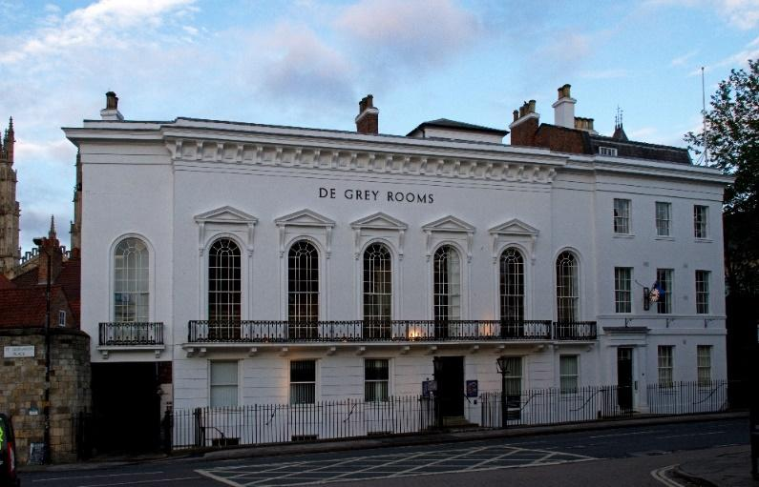Our first social will be at the fabulous De Grey Rooms in in centre of York. The theme is ‘Represent Your Scene’, so make sure you’re wearing something that shows you’re loud and proud of where you’ve come from!   
Address:  
 De Grey Rooms  
 St. Leonards Place  
 York  
 YO1 7HB

Parking

The nearest car park is Bootham Row car park. From The De Grey Rooms, take a slight left onto Bootham, A19. Take the first right onto Bootham Row, and take the first right again onto Percy Street. The car park is on this street.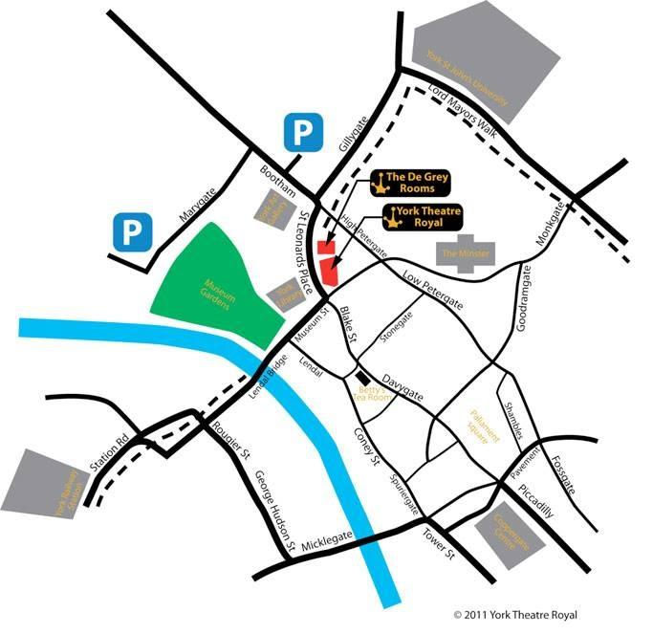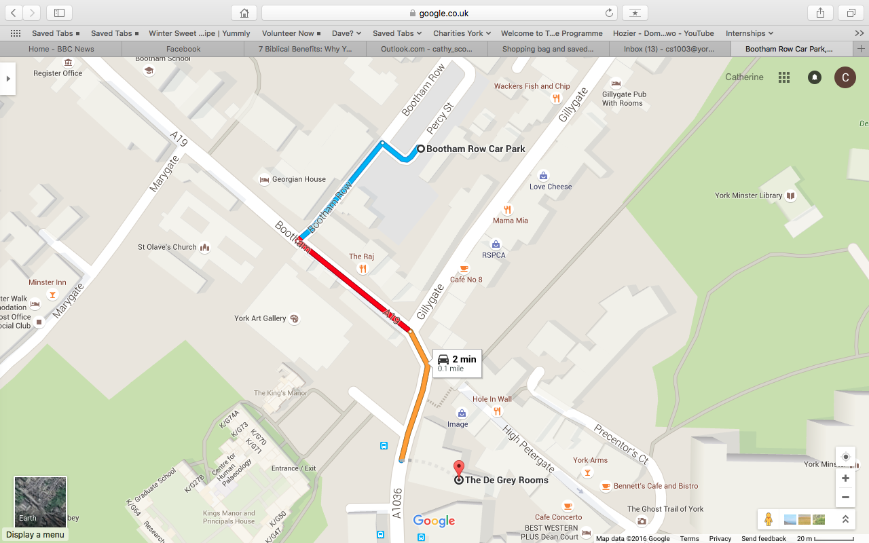

# Saturday Social: Behind the Silver Screen

Are you ready for our big Saturday night social? Whip-Ma-Whop-Ma-Hop 2016 is proud to present the Fairytale Ball at the magical Guildhall! Whether you’re dressed as a prince or a princess, a frog or a toad, a witch or just plain evil, be prepared for a magical evening of spell-binding swing-outs and tantalising tuck-turns…

This social venue is licensed so you can bring your own alcohol.

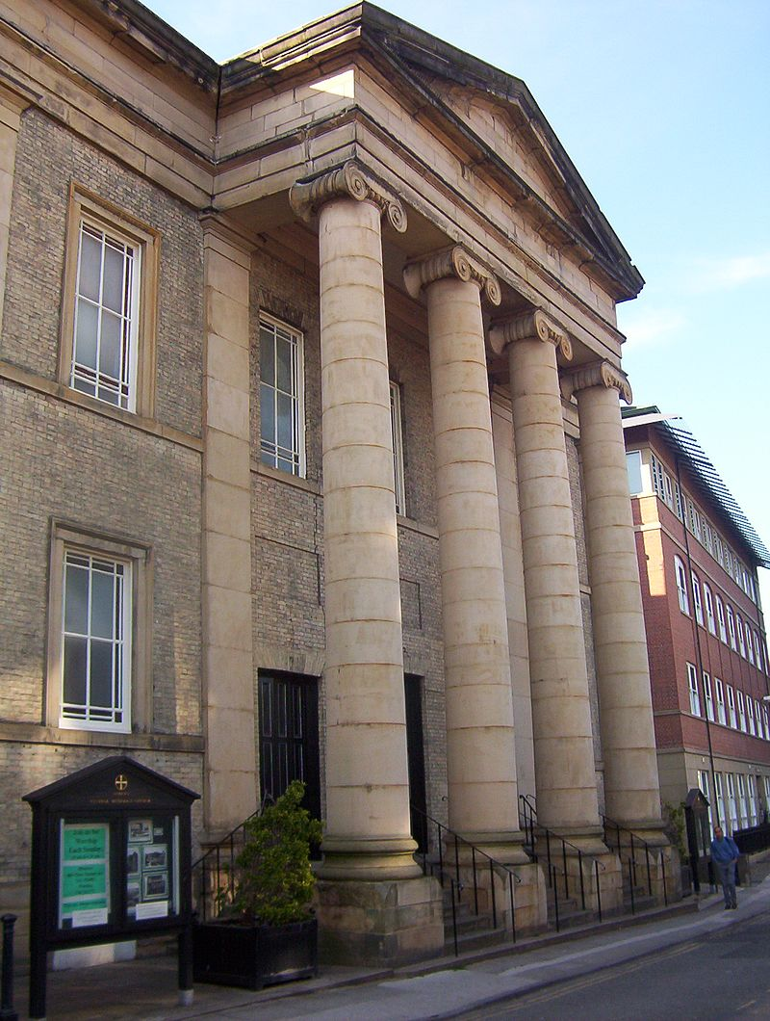Address:  
 Central Methodist Church  
 St. Saviourgate  
 York   
 YO1 8NA

**PICTURES TO BE CHANGED**

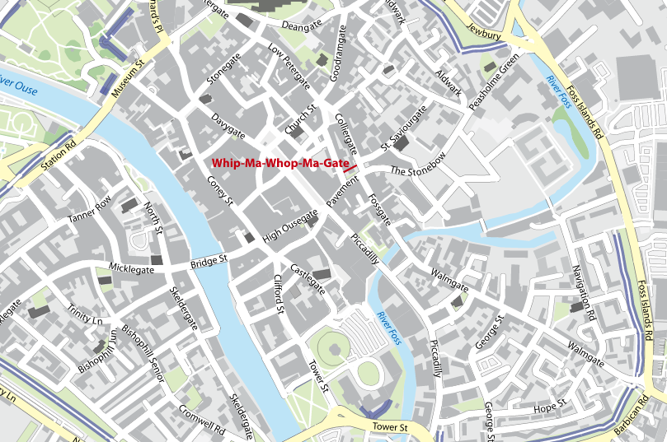

**Central Methodist Church**

# After Party

Wait… don’t stop yet! After the main Saturday event, we invite you to an after part at Macumba Cocktail bar. York is a small city, so its only 5 minute walk from Central Methodist Church!

DJs will be playing a variety of songs, including blues, lindy and xxx

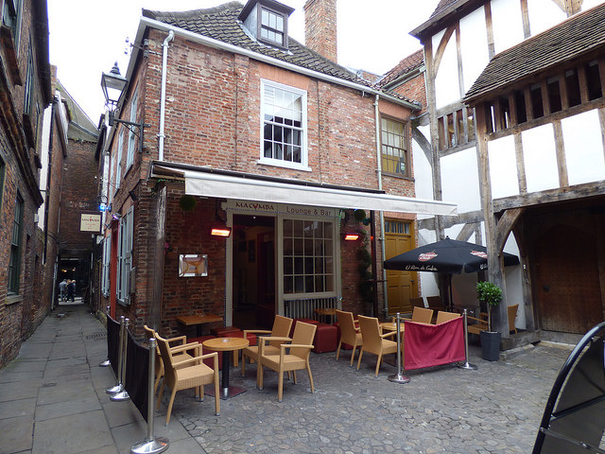The upstairs is for us only, where we’ll have our own space for dancing. The other floors are open to the public, so feel free to explore, sit and chat, and go try show off your moves on the public dance floor!

Address:  
 Macumba Cocktail Bar  
 3 Coffee Yard  
 York  
 YO1 8AR

Parking

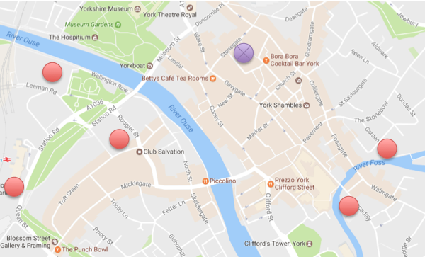Nearby car parks are NCP Queen Street (YO24 1AD), Esplanade Car Park (YO1 6FZ), NCP Tanner Row (YO1 6JL), NCP Piccadilly (YO1 9NX), Q-Park Shambles (YO1 7NT).

# Sunday Social: Pyjama Party!

Exhausted after two days of dancing? Well we’ve got the perfect theme for you! Dress in your finest pyjamas, but swap the slippers for your dancing shoes, and get prepared for one last night of fun!

Address:  
 Clements Hall  
 Nunthorpe Road  
 York  
 YO23 1BW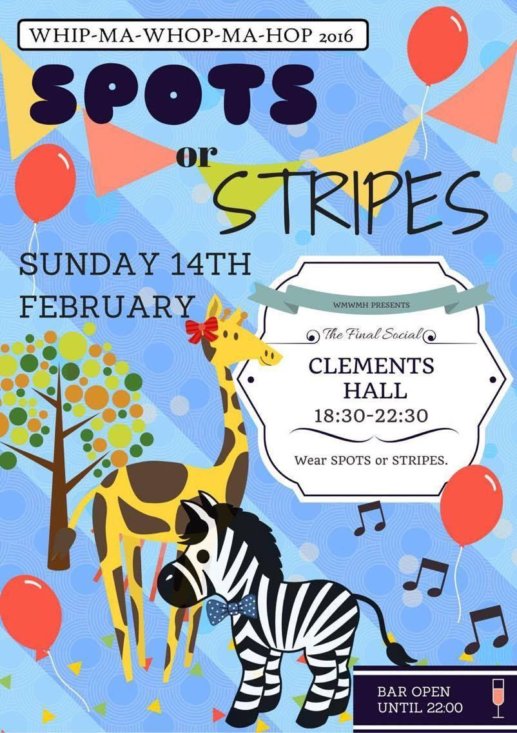

(SatNav: use YO23 1BP or YO23 1BS to navigate to the front of the building on Nunthorpe Road)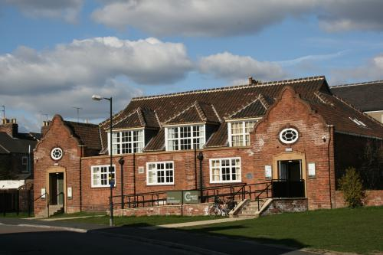

**PICTURE NEEDS CHANGING**

Parking

# Finally…

We hope you really enjoy Whip-Ma-Whop-Ma-Hop 2017! Go all out, dance with lots of people and most of all, have fun!  
  
Thanks…  
We’d like to thank Scott Cupit, Robyn Larsen, Cat Foley, Cam Mitchell, Matt Lane and Jenny Clapp for coming to teach for us this weekend.  
  
Big thanks also to Alex Parker, Matt Lane, George Jackson, Laura Cook, Chris Gammie, Ella Corbin and Matilda Marshall for offering to DJ at the social dances.

And last but not least, thanks to the committee who have worked really hard to organise this weekend:

Sarah Weinberg, *President*

Laura Cook,   
*Events Coordinator*

Vikki Gale,   
*Performance Coordinator*

Cathy Scott,   
*Newbie Rep*

Bethan Thomas, *Treasurer*

Grace Sansom,   
*Teaching Coordinator*

Tabitha Spear, *Merchandise Rep*

Nick Chan,   
*Newbie Rep*

Tilly Baker Hine,   
*Secretary*

Imogen Harris,   
*Press & Publicity Officer*

Emily Walker,   
*Social Secretary*

